LAPORAN WSL

1. Buat Microservice 1

* lxc-create --name microservice1 --template download -- --dist "ubuntu" --release "focal" --arch amd64

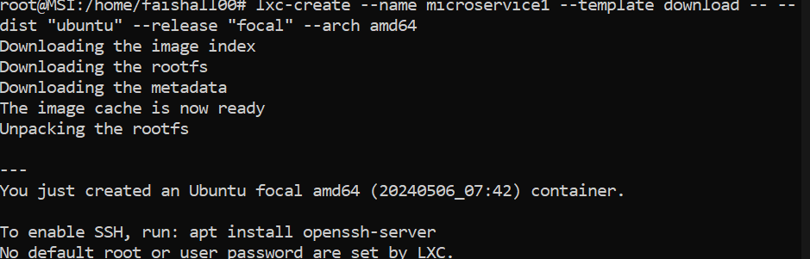

1. buat microservice 2

* lxc-create --name microservice2 --template download -- --dist "ubuntu" --release "focal" --arch amd64

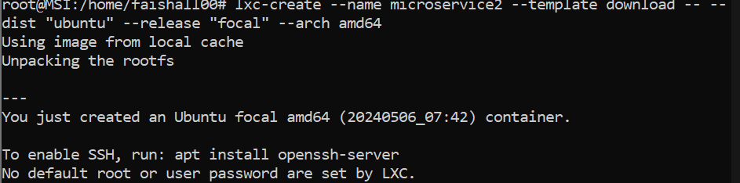

1. command # ip r -> untuk mengetahui ip dan subnet server dan microservice

* ip r



* lxc-ls -f



1. masuk ke microservice1 dan microservice2 lalu install nginx dan network manager

* lxc-attach -n microservice1

sudo apt install nginx nginx-extras

sudo apt install network-manager

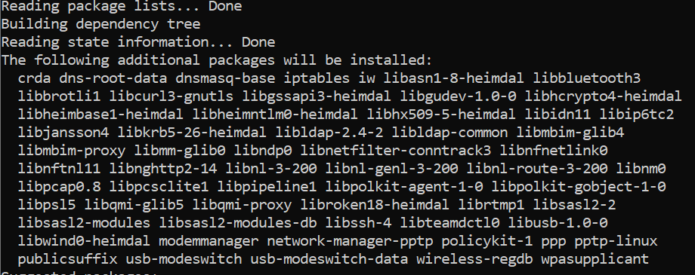

exit

lxc-attach -n microservice2

sudo apt install nginx nginx-extras

sudo apt install network-manager

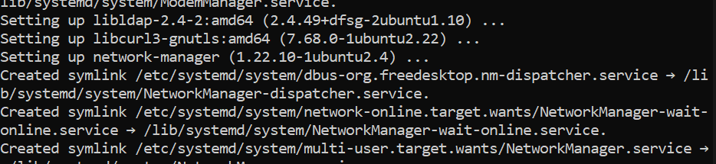

1. setting static IP di microservice1

* nano /etc/netplan/10-lxc.yaml

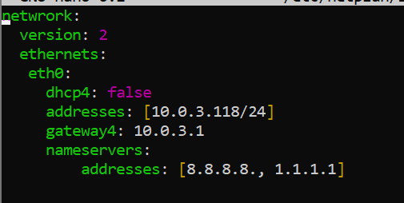

* sudo netplan apply

ifconfig

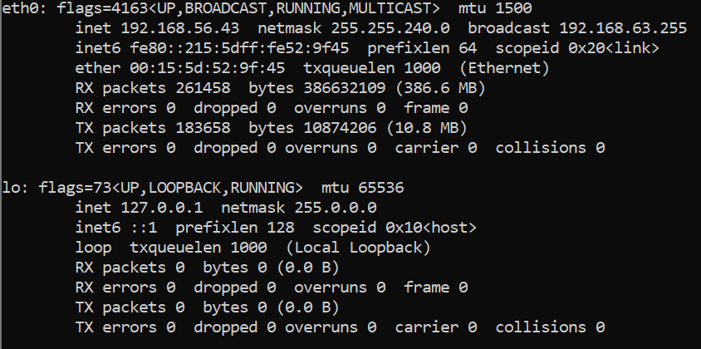

1. setting network interfaces

* nano /etc/network/interfaces

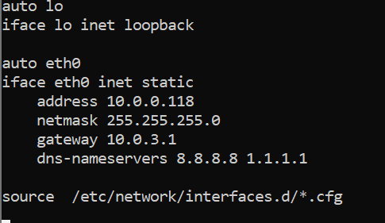

1. restart network manager

* sudo systemctl restart NetworkManager

ifconfig

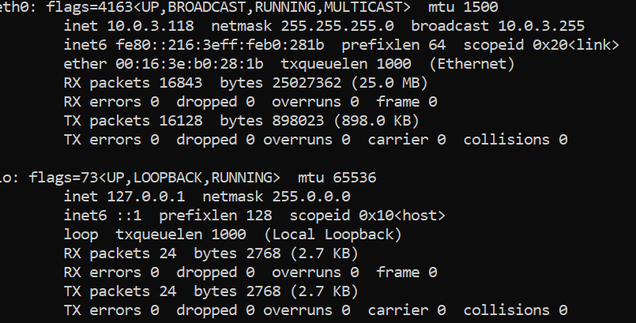

1. Setting ngix

* cd /etc/nginx/sites-available

touch microservice1.dev

nano microservice1.dev

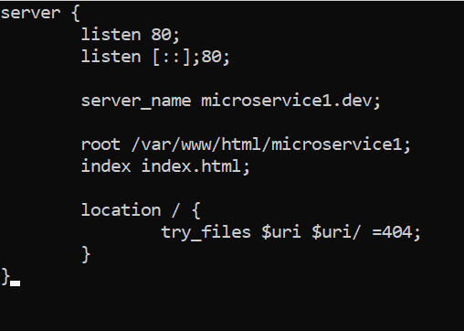

* cd ../sites-enabled
* ln -s /etc/nginx/sites-available/microservice1.dev .
* nginx -t
* nginx -s reload
* nano /etc/hosts

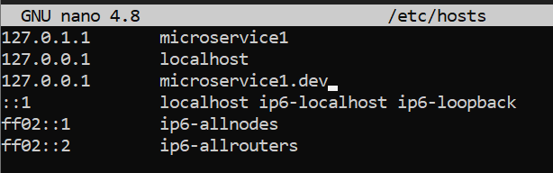

* cd /var/www/html
* mkdir microservice1
* cp index.nginx-debian.html microservice1/index.html
* cd microservice1
* nano index.html

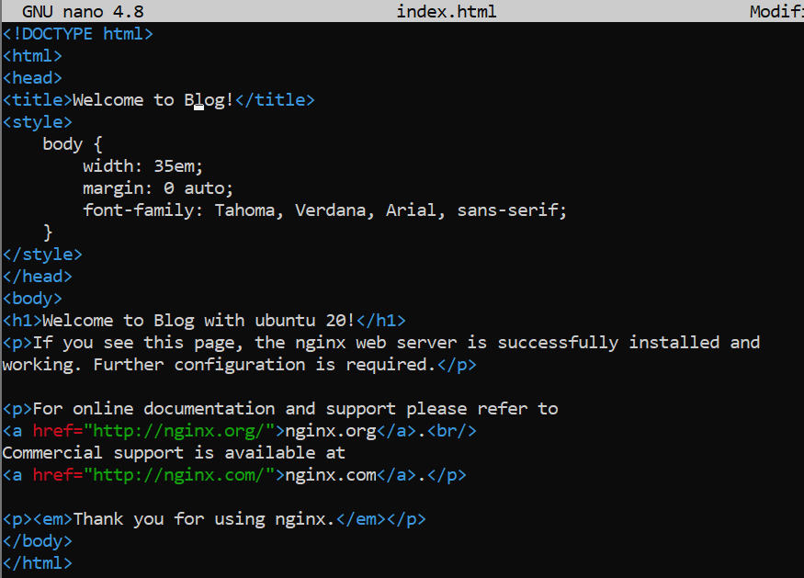

1. Lakukan curl ke microservice1

* curl -i <http://microservice1.dev>

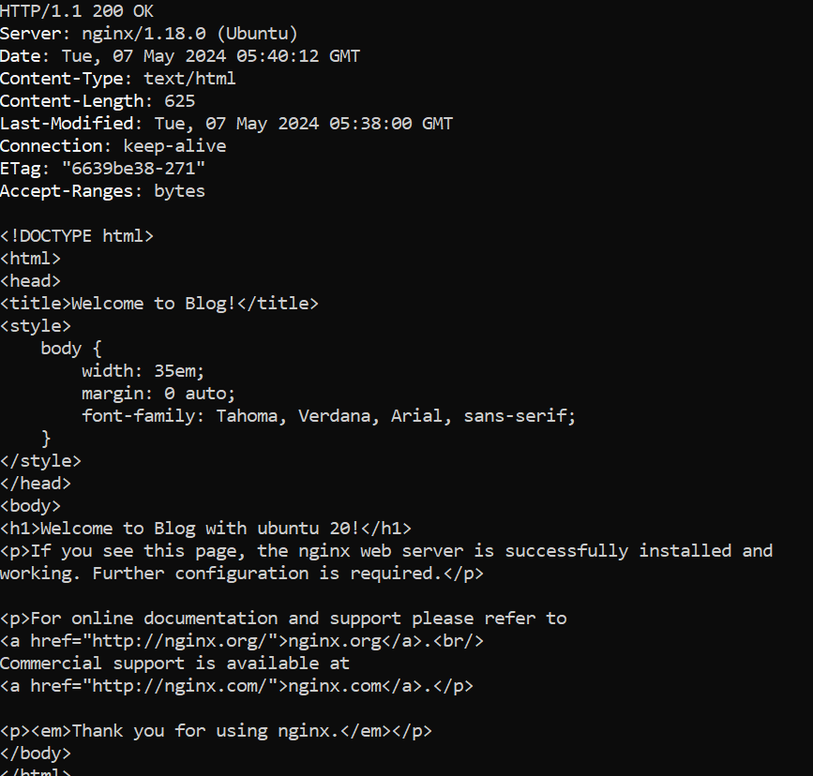

1. Setting Static IP microservice2

* apt install nano net-tools curl
* sudo nano /etc/netplan/10-lxc.yaml

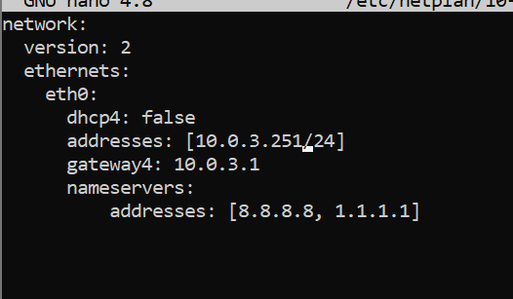

* sudo netplan apply
* ifconfig

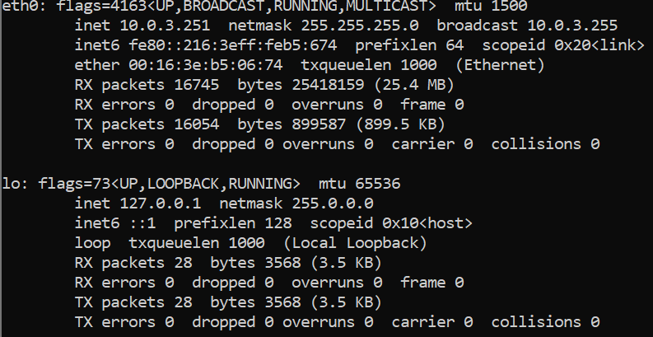

Setting network interfaces

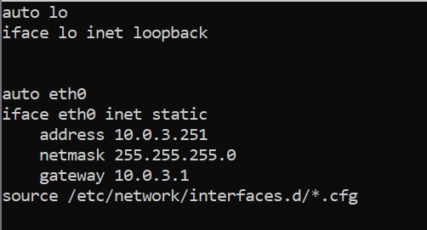

* sudo systemctl restart NetworkManager
* ifconfig

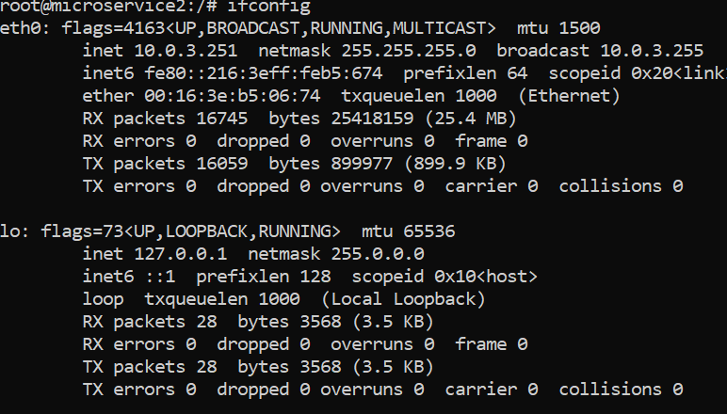

Setting nginx

* cd /etc/nginx/sites-available
* touch microservice2.dev
* nano microservice2.dev

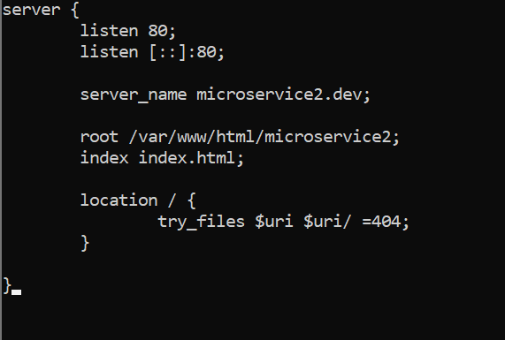

* cd ../sites-enabled
* ln -s /etc/nginx/sites-available/microservice2.dev
* nginx -t
* nginx -s reload
* nano /etc/hosts

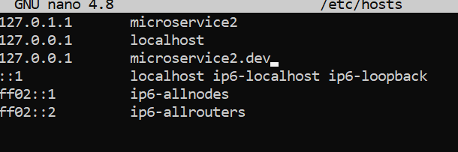

* cd /var/www/html
* mkdir microservice2
* cp index.nginx-debian.html microservice2/index.html
* cd microservice2
* nano index.html

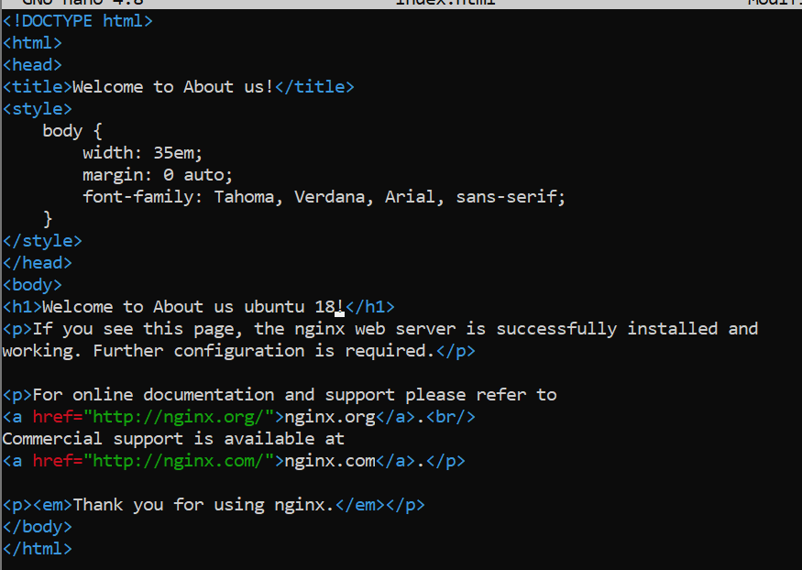

* curl -i http://microservice2.dev

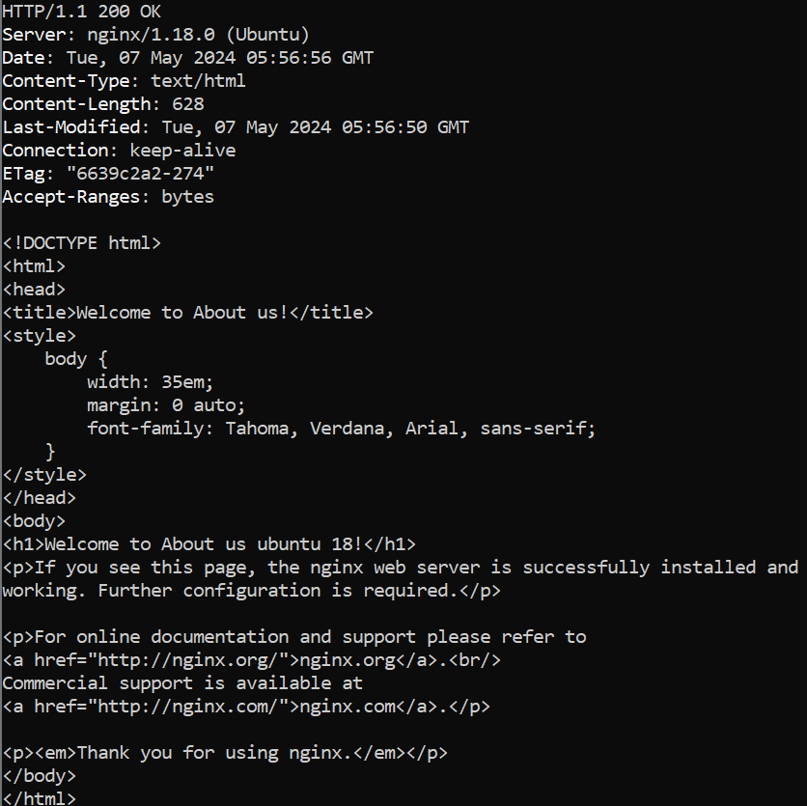

1. Setting hosts di WSL

* nano /etc/hosts

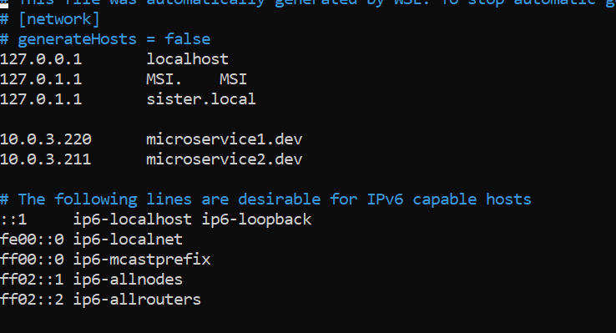

* cd /etc/nginx/sites-available
* touch sister.local
* nano sister.local

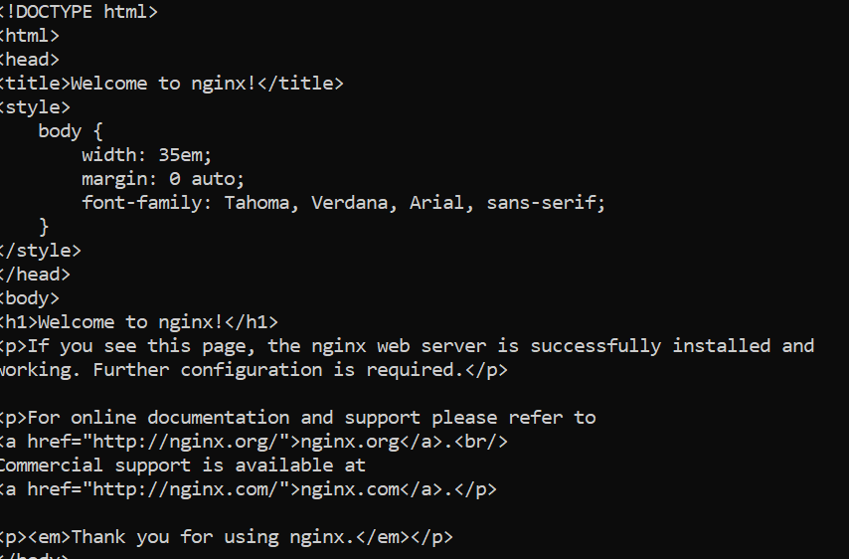

* cd ../sites-enabled
* sudo ln -s /etc/nginx/sites-available/sister.local .
* sudo nginx -t
* sudo nginx -s reload

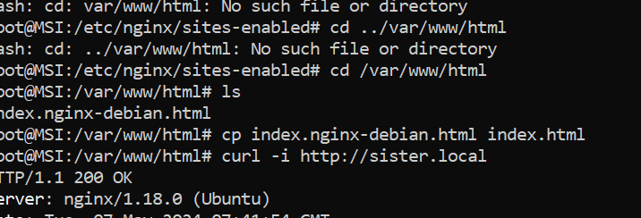

* curl -i <http://sister.local>
* curl -i <http://sister.local/blog>  
  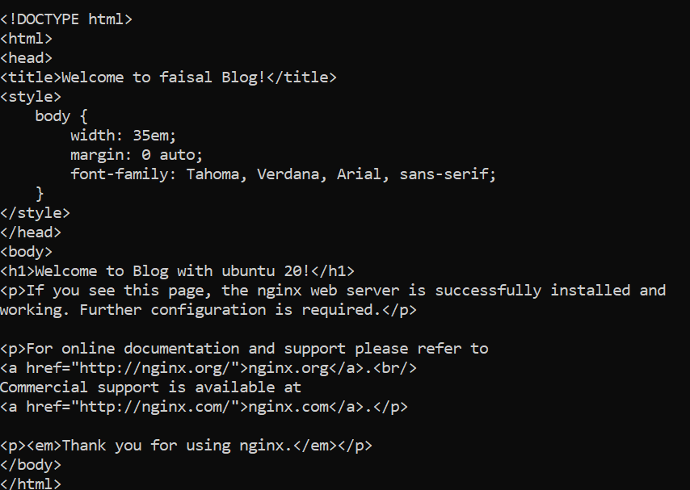
* curl -i <http://sister.local/aboutus>

